COMP9311 - Database System

Assignment 1

Question 1: 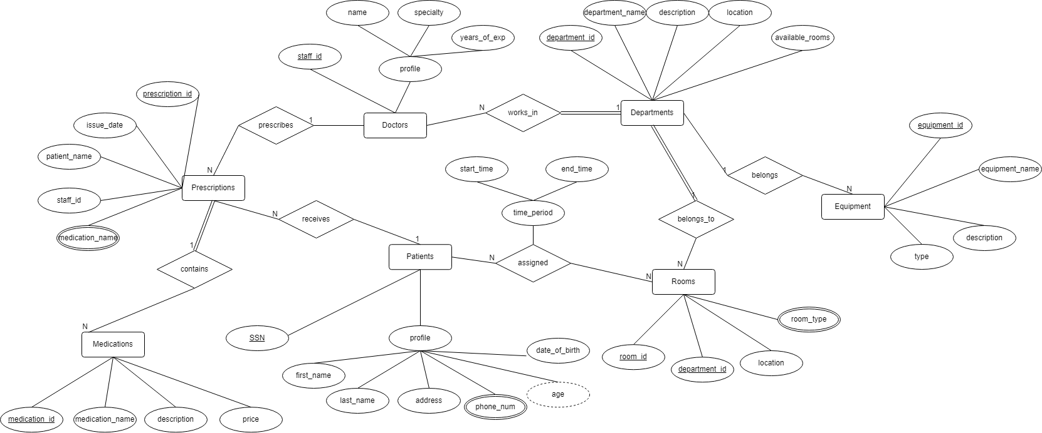

1

1

Question 2:

Question 3:

1.

AvgTotalSpending = γ AVG (salePrice) (Sale)

TotalSpending = γ cusID, SUM (salePrice) (Sale)

CustCarManufacturers = π cusID, manuID (Sale ⋈ Car)

CustManufacturerCount = γ cusID, COUNT (DISTINCT (manuID)) (CustCarManufacturers)

EligibleCust = σ COUNT (DISTINCT (manuID) > 2) ​(CustManufacturerCount)

HighSpenders = σ TotalSpending > AvgTotalSpending​ (TotalSpending × AvgTotalSpending)

**FinalResult** = π cusName ​(Customer ⋈ (EligibleCust ∩ HighSpenders)

2.

ServiceCount = γ carID, sYear, COUNT (serID) ​(Service)

OverServicedCars = π carID ​(σ COUNT (serID) > 1 ​(ServiceCount))

OverServicedManufacturers = π manuID ​(OverServicedCars ⋈ Car)

EligibleManufacturers = π manuID ​(Manufacturer) – OverServicedManufacturers

HighRatedSaleperson = σ rating > 4.5​ (Salesperson)

HighRatedSales = π carID​ (Sale ⋈ HighRatedSaleperson)

HighRatedManufacturer = π manuID​ (HighRatedSales ⋈ Car)

**FinalResult** = π makName (​(EligibleManufacturers ∩ HighRatedManufacturer) ⋈ Manufacturer)

3.

StartYear = γ salpID, MIN (saleYear) ​(Sale)

SalesYearCount = γ salpID, COUNT (DISTINCT (saleYear)) ​(Sale)

TotalYears = π salpID, (2024−startYear+1) ​(StartYear)

ConsistentSales = π salpID ​(σ COUNT (DISTINCT (saleYear)) = (2024−startYear+1) (SalesYearCount ⋈ TotalYears))

AvgYearSale = γ saleYear, AVG (salePrice) ​(Sale)

AboveAvgSales = π salpID ​(σ salePrice ≥ avgPrice ​(Sale ⋈ AvgYearSale))

**FinalResult** = π salpName ​((ConsistentSales ∩ AboveAvgSales) ⋈ Salesperson)

4.

ServiceCount = γ carID, COUNT (DISTINCT (sYear)) ​(Service)

SingleServiceCars = π carID ​(σ COUNT (DISTINCT (sYear)) = 1 ​(ServiceCount))

SaleService = π carID, saleYear, sYear​ (Sale ⋈carID = carID​ Service)

ThreeYearCars = π carID ​(σ sYear ≥ saleYear + 3​ (SaleService))

**FinalResult** = SingleServiceCars ∩ ThreeYearCars